1) Indirect Addressing with Arrays:
Define an array of 10 BYTE elements named numArray initialized with the values 0x10, 0x20, ..., 0xA0 (incrementing by 0x10).
Use indirect addressing to load the value of the 5th element (index 4) into the BL register.
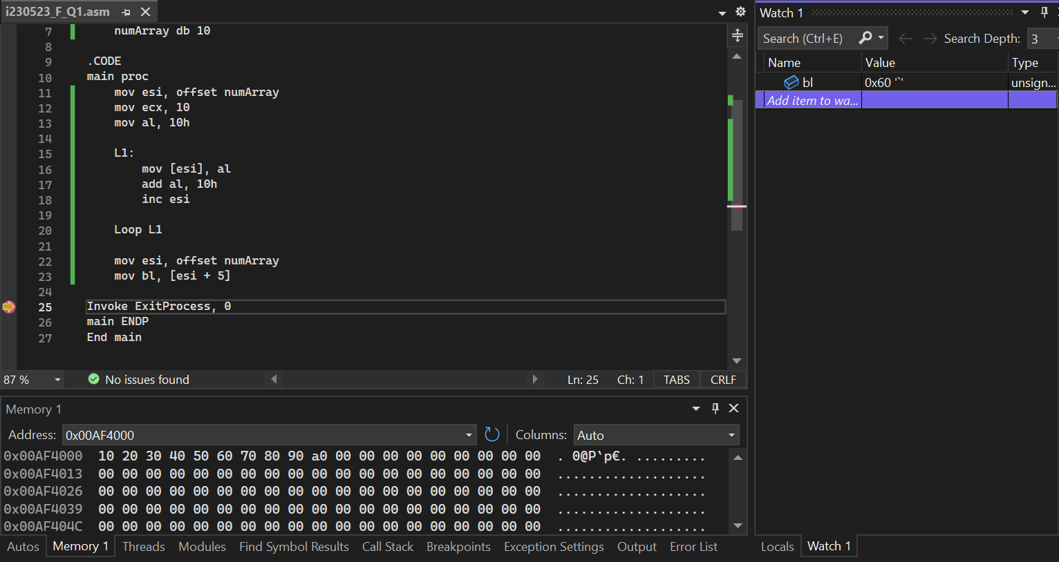
2) Offset Calculation with Mixed Types:
Define variables var1 (BYTE), var2 (WORD), var3 (DWORD), and var4 (DWORD) in that order.
Use the OFFSET operator to move the address of var2 and var4 into the SI and DI registers respectively.
Calculate the offset of var3 from the beginning of the data segment and move this value into the BX register.
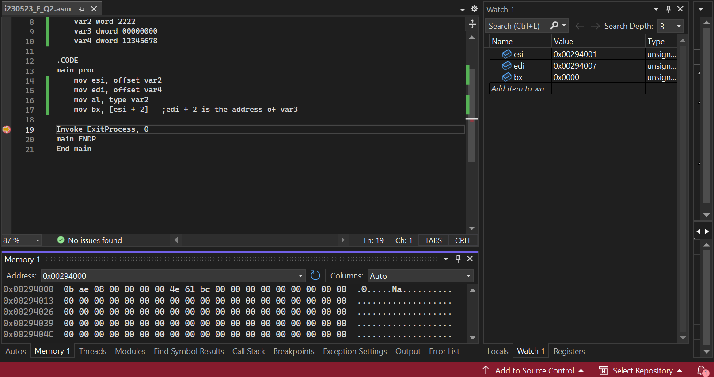
3) Pointer Arithmetic and PTR Operator:
Define a DWORD variable largeValue initialized to 0xABCDEF12.
Use the BYTE PTR, WORD PTR, and DWORD PTR operators to extract and move the following into appropriate registers:
- The low-order byte to AL
- The middle 16-bit word to CX
- The high-order DWORD to EDX
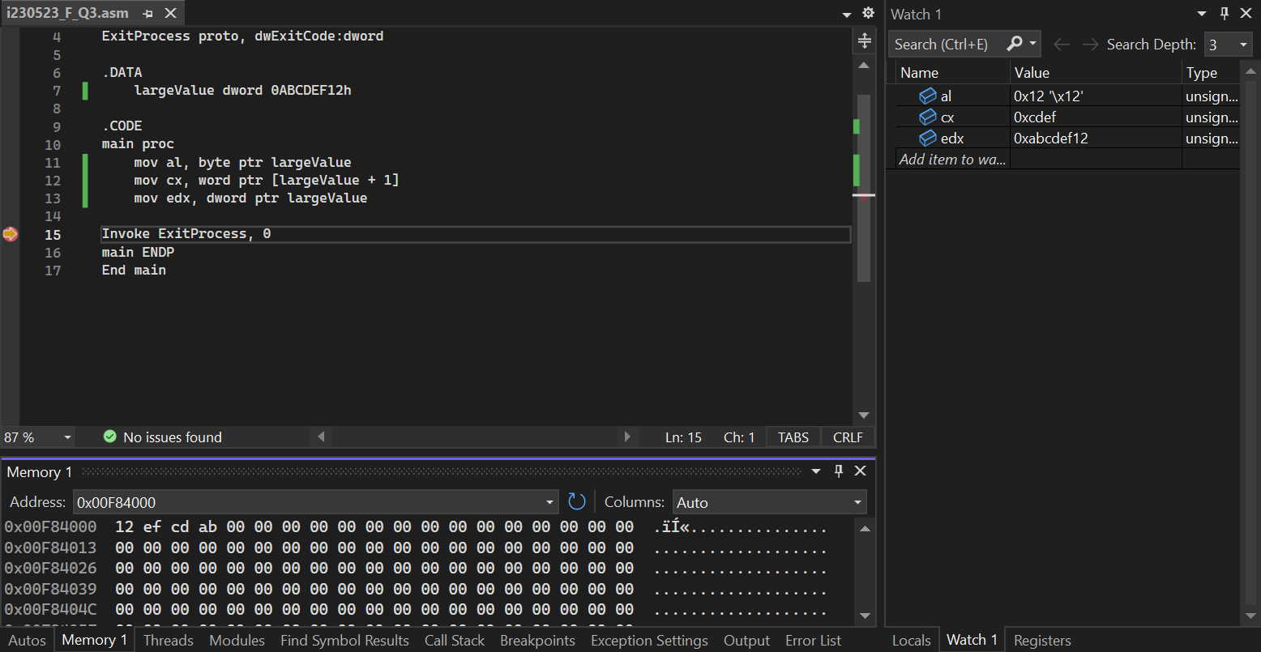
4) Alignment Directive:
Define several variables (BYTE, WORD, DWORD) with the following alignments:
- byteAlign aligned on a 1-byte boundary
- wordAlign aligned on a 2-byte boundary
- dwordAlign aligned on a 4-byte boundary
Ensure dwordAlign follows immediately after wordAlign without any extra space in between.
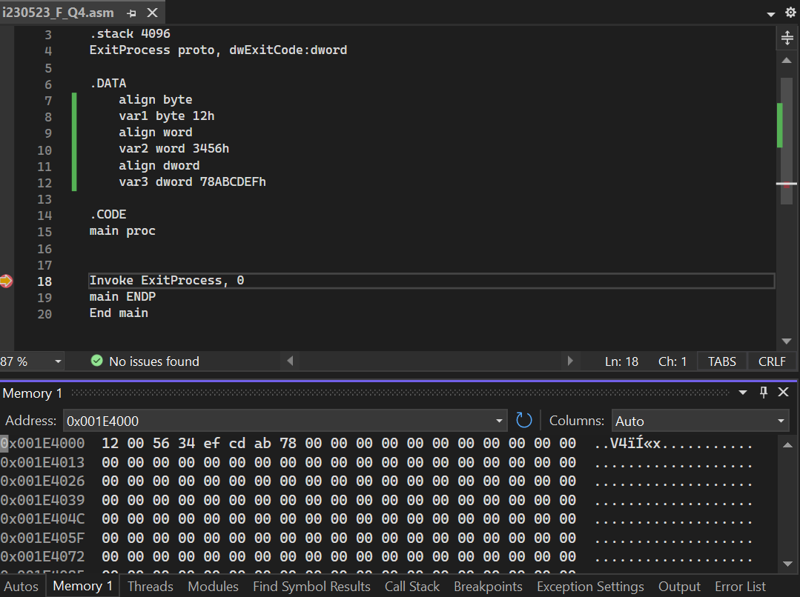
5) Pointer to Array Elements:
Define an array dataArray of 4 DWORD elements: 0x00000001, 0x00000002, 0x00000003, 0x00000004.
Define a DWORD variable ptrToArray that holds the offset of dataArray.
Load the address of the second element in dataArray into the ESI register using the pointer.
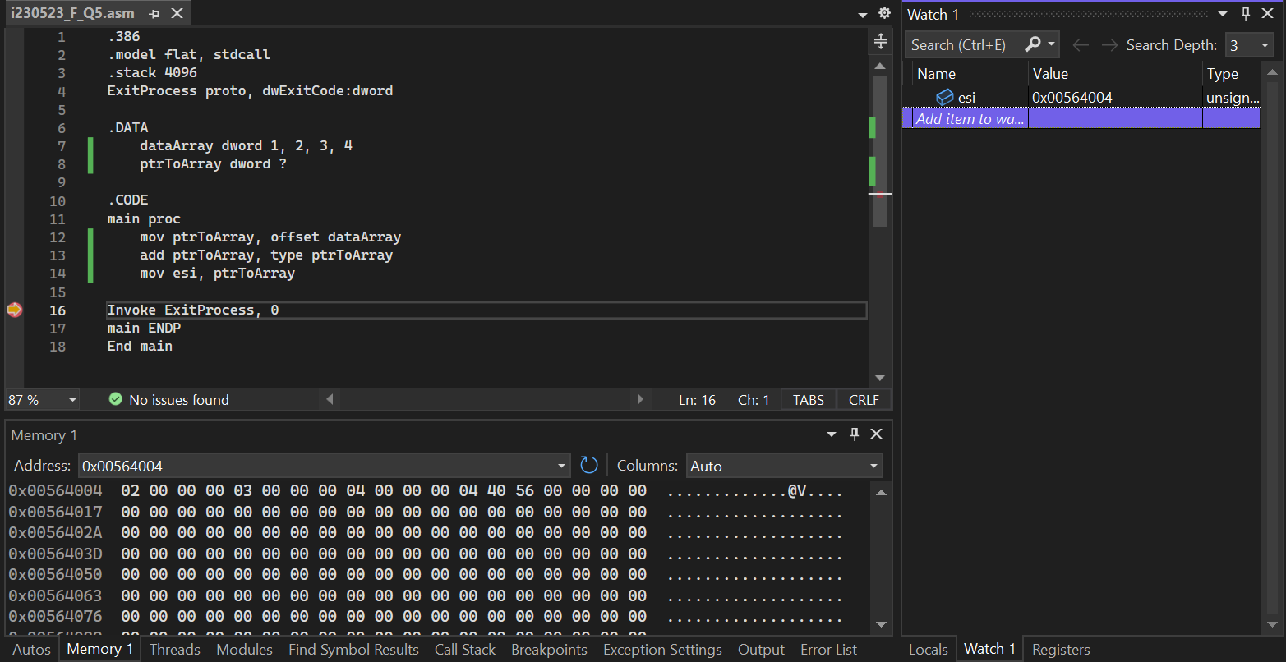
6) Complex Indirect Addressing:
Define an array complexArray of 3 WORD elements: 0x1234, 0x5678, 0x9ABC.
Define a pointer indexPtr as a DWORD to hold an index value.
Use indexPtr to calculate the address of the second element in complexArray and load this value into AX.
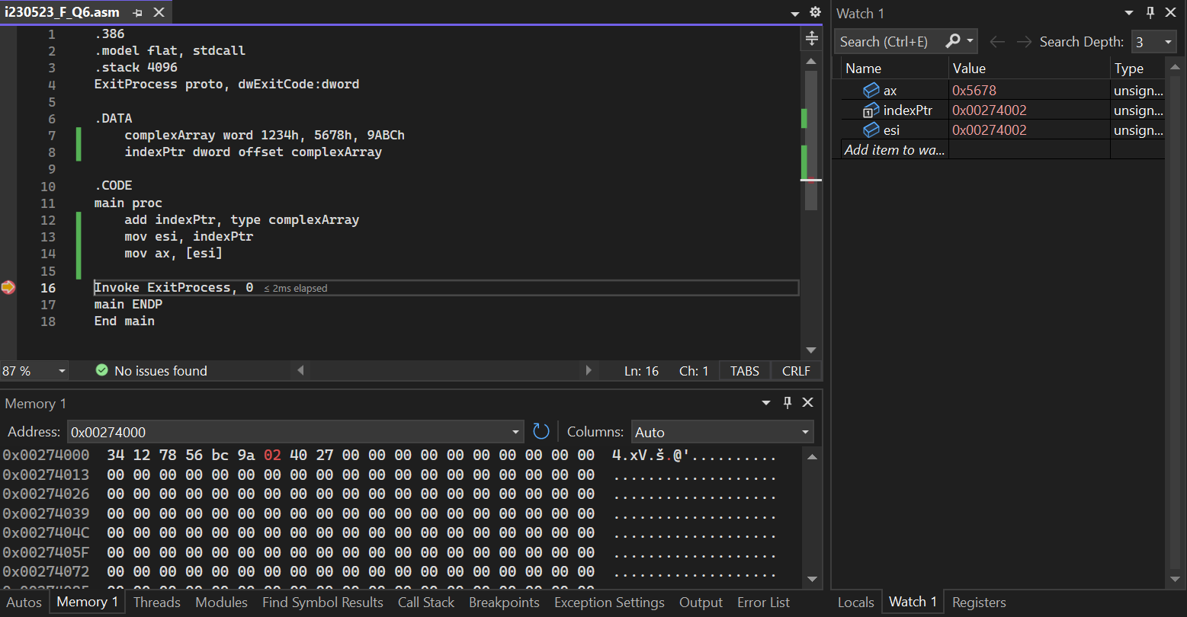
7) Calculating Array Offsets:
Define a WORD array data of 6 elements with arbitrary values.
Calculate the address of the 4th element in data and move this address into SI.
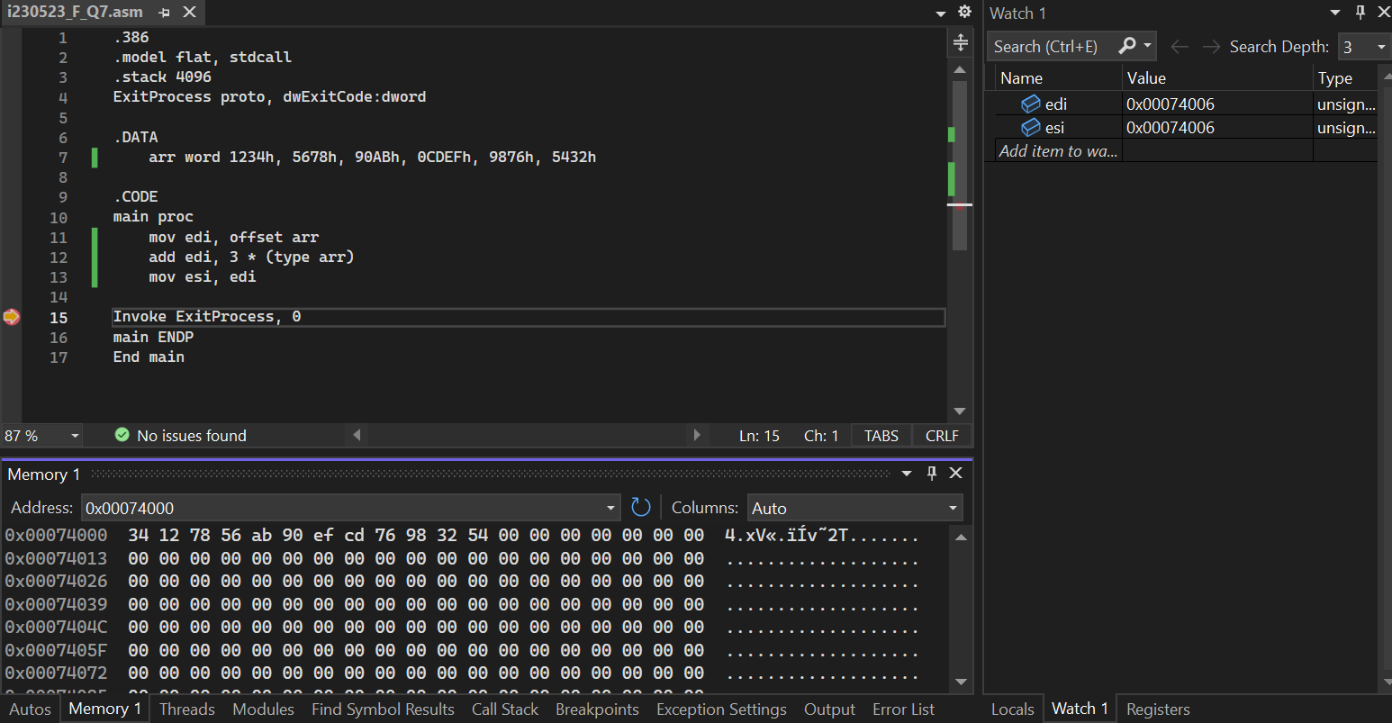
8) Aligning Data with Padding:
Define a BYTE variable, followed by a DWORD variable, ensuring the DWORD is aligned on a 4-byte boundary.
Insert the necessary alignment directives and determine the actual memory offsets.
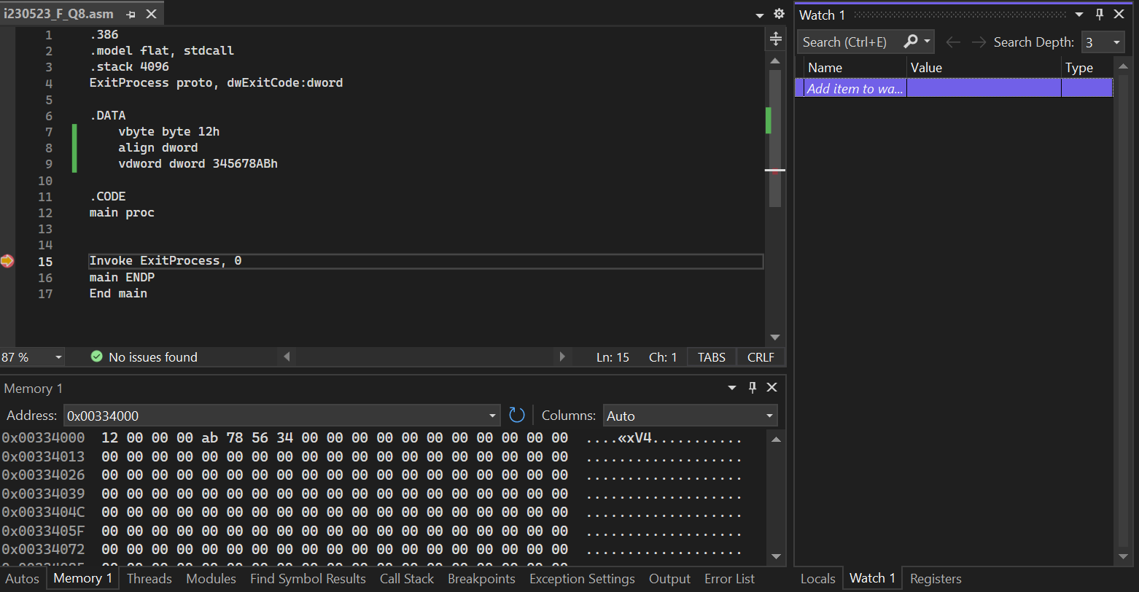

9) Dynamic Pointer Arithmetic:
Define a DWORD array dynamicArray of 3 elements: 0x10000000, 0x20000000, 0x30000000.
Create a pointer variable dynamicPtr that initially points to the first element.
Move all element’s value into EAX using pointer arithmetic and copy it another array name copyarray
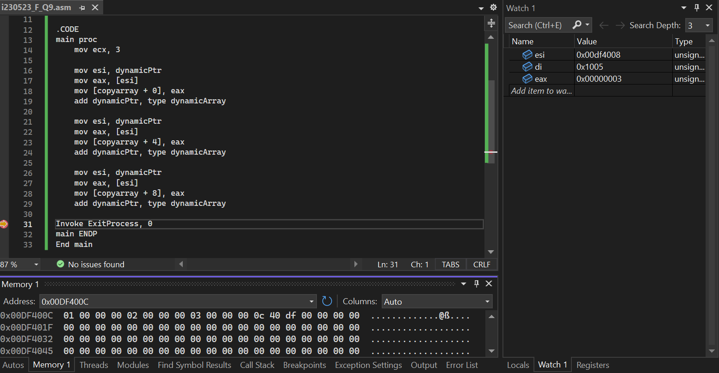
10) Combining Direct and Indirect Addressing:
Define a BYTE variable baseValue initialized to 0xFF and a WORD variable offsetValue initialized to 0x0020.
Use indirect addressing to compute the final address by adding offsetValue to baseValue's address and move the resultant value into AL.

